Assignment 3.2

• Create a file with the name max-temp.txt in the local file system and add 10-15 records with two columns for date and temperature and save it as max-temp.txt Example: dd-mm-yyyy, temperature 10-01-1990, 10 10-02-1991, 20

● Copy the above max-temp.txt file from the local file system to HDFS in the /user/acadgild/hadoop path.

● Change the permission of the file /user/acadgild/hadoop/max-temp.txt, such that only the owner and the group members should have the r-w-x permissions. Others should have only read the permission on the above file.

● Share the screenshot of the commands used with the output.

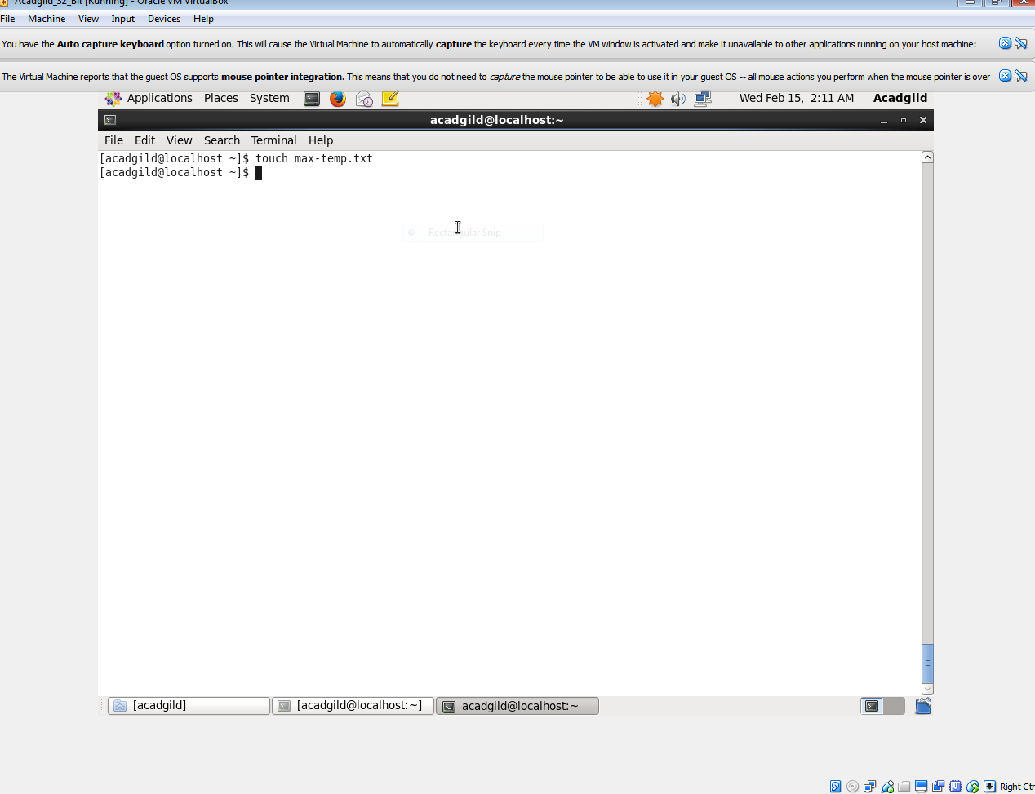

touch max-temp.txt:

this command will make a txt file of name max-temp in local host

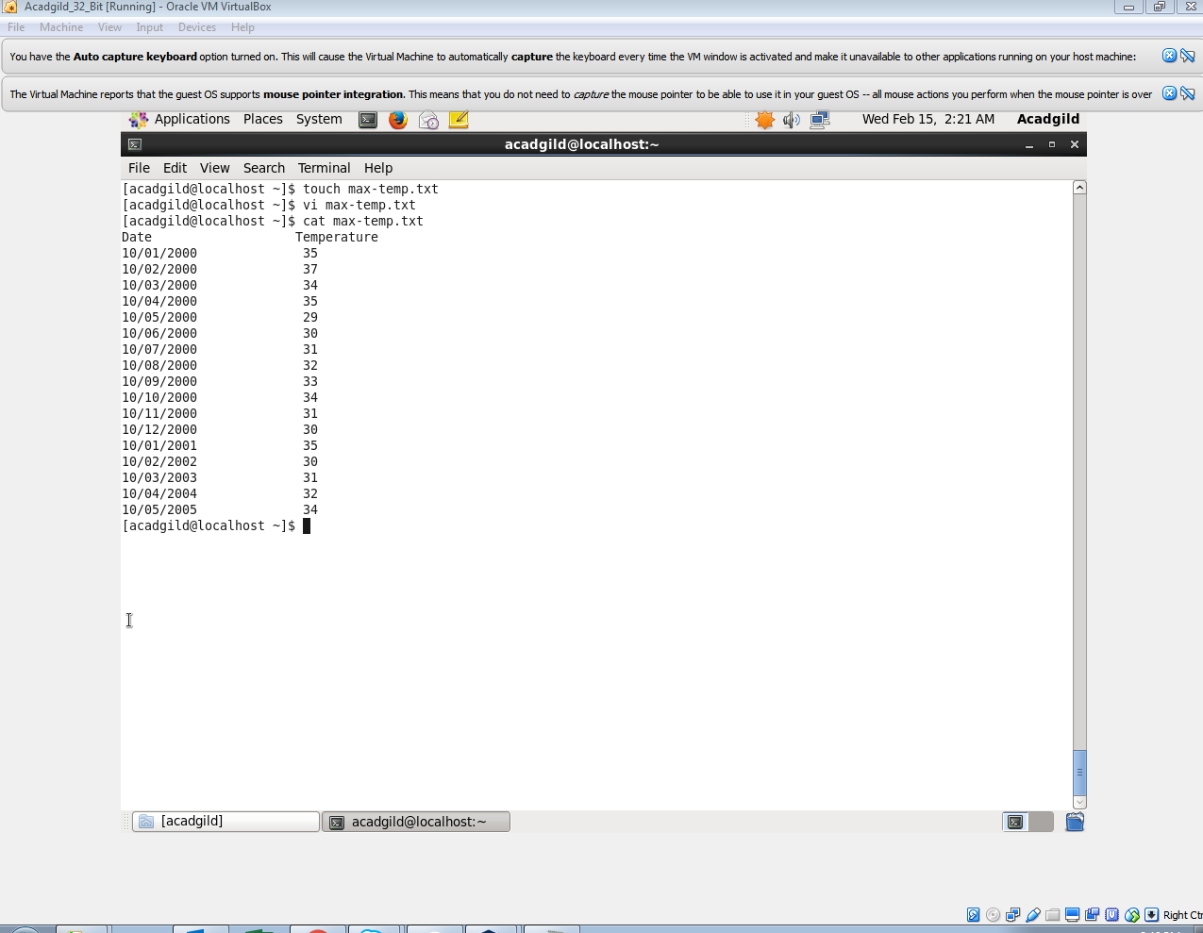

Vi max-temp.txt:

It opens the vi editor press I to insert txt

Cat max-temp.txt:

Display contents of file

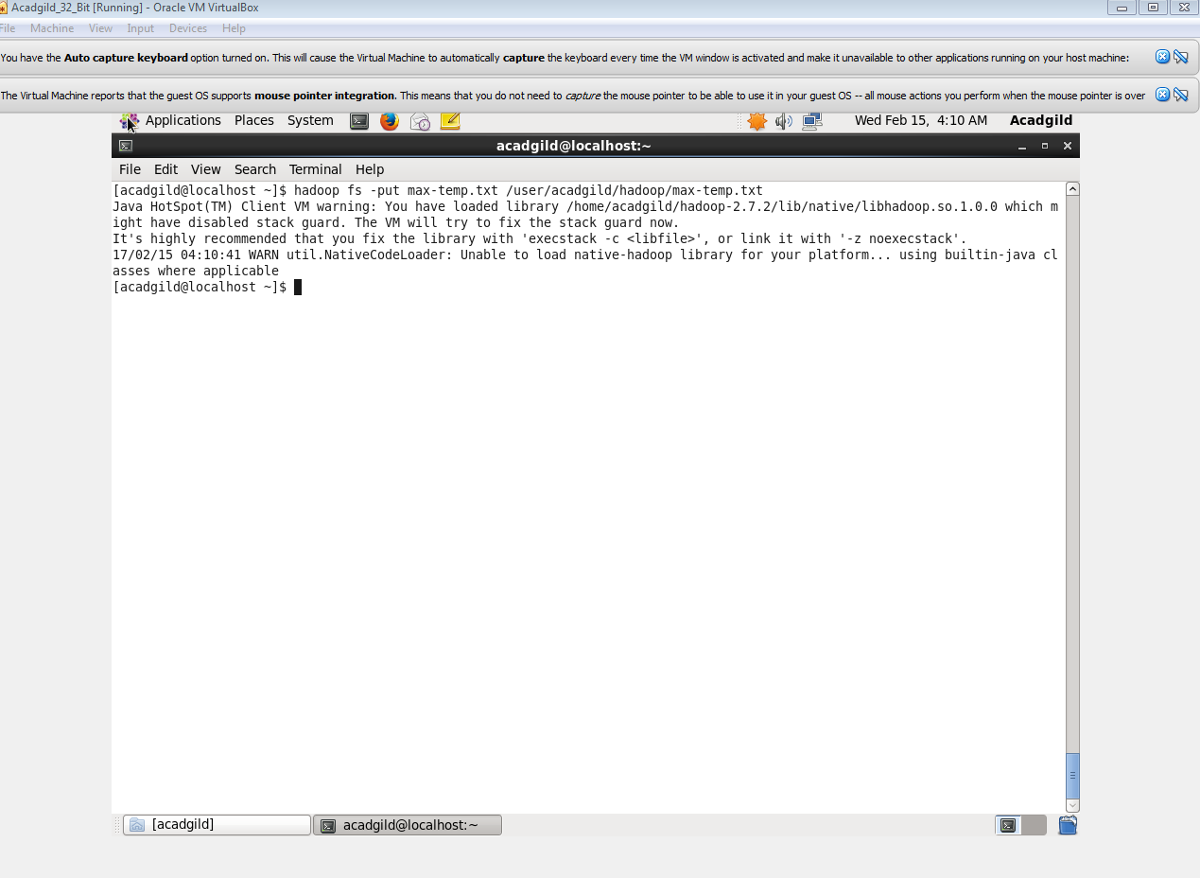

Hadoop fs –put max-temp.txt /user/acadgild/hadoop/max-temp.txt

Put max-temp.txt from local host to Hadoop inside acadgild folder

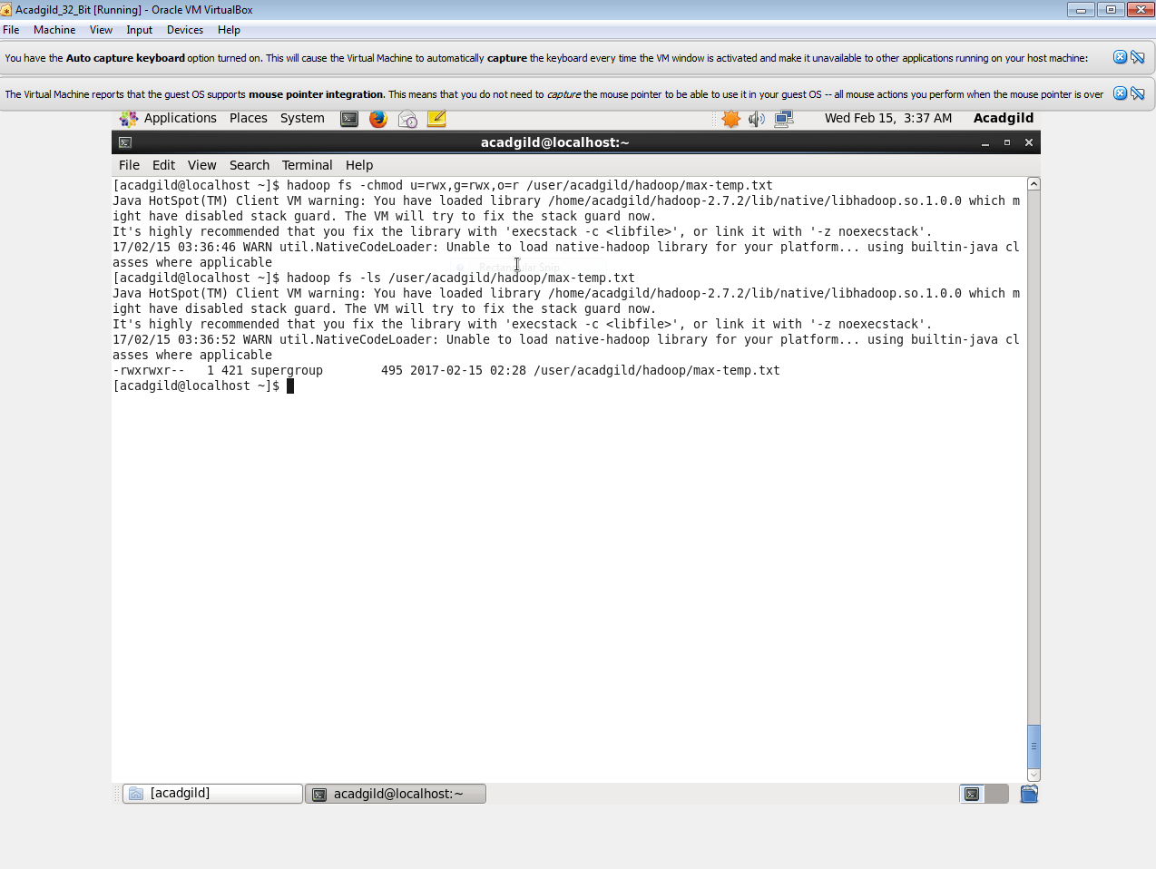

Hadoop fs –chmod u=rwx, g=rwx,o=r /user/acadgild

To give permission for u=user,g=group,o=others